**Download the attached “EvanSmithC868” zip file, and unzip it.**

**1. Launch the program**

To launch the application, unzip the “EvanSmithC868” archive. After EvanSmithC868 has been unzipped, select and open the file entitled “TechGopherScheduler.bat”, located inside the EvanSmithC868 folder. It will launch a script that will launch the program from a Java Runtime Executable.

**2. Login**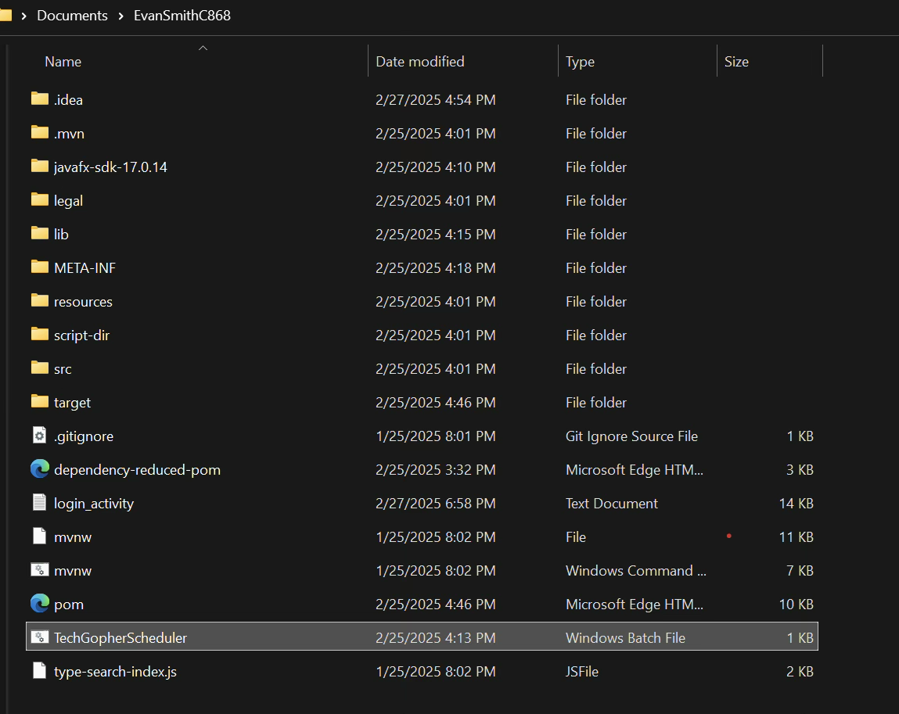

After running “TechGopherScheduler”, the login screen will appear. Enter the test user credentials by entering “test” in both username and password, and then press Login.  
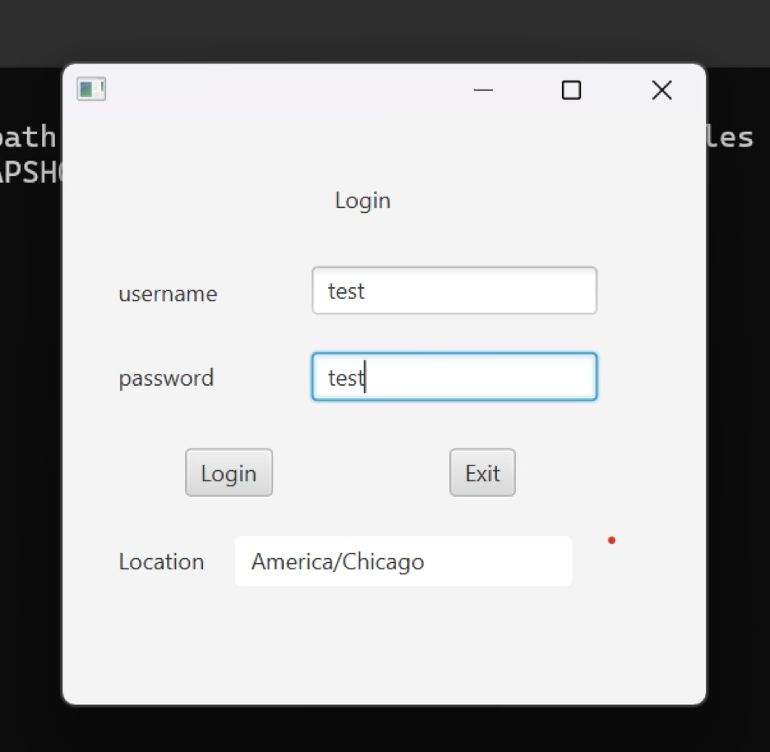

**3. Main Screen**

After pressing “Login”, a notification will appear, informing the User of upcoming appointments. Because there are not currently upcoming appointments, the notification will be “No upcoming appointments”. Press “OK” to make the main menu appear. This menu contains access to the rest of the application, including Appointments, Customers, and Reports. There is also a button to exit the application.    
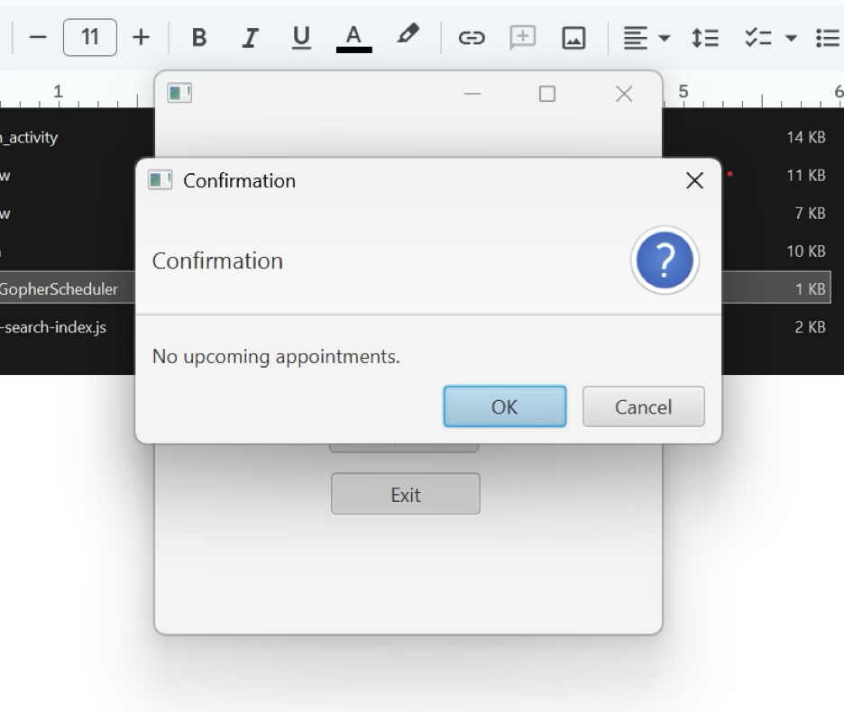

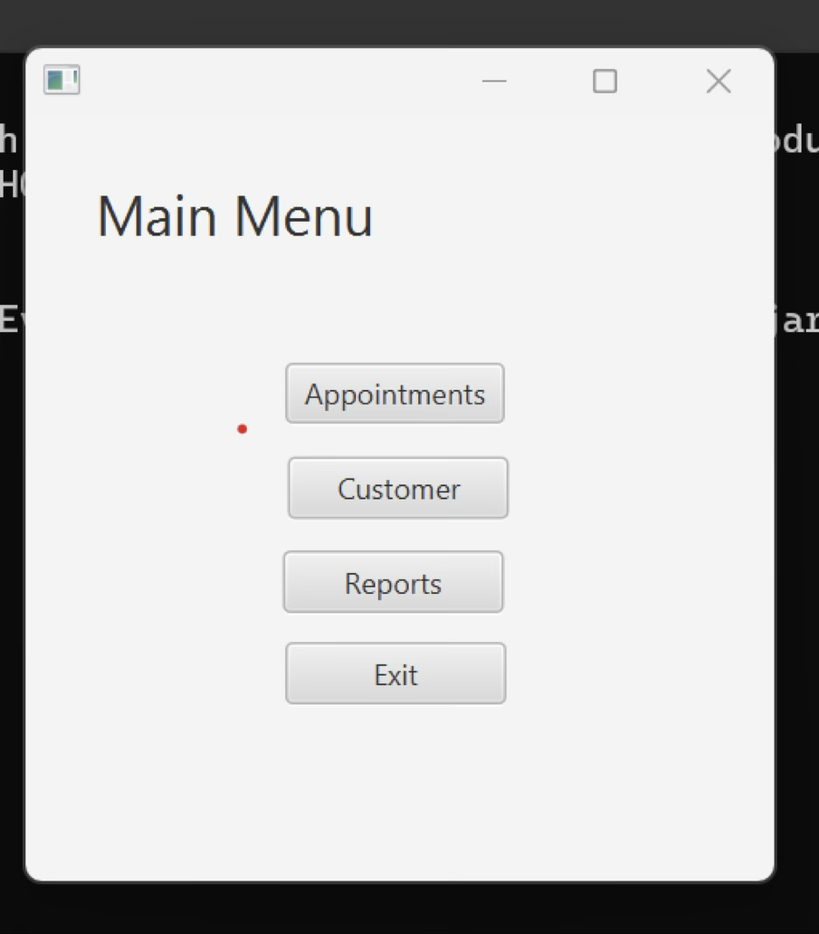  
**Appointments**

The appointments screen is the primary screen from which appointments are accessed, created, updated, and removed. The largest element is the table which is populated with current appointment information. Column headers Appointment, Title, Description, Location, Type, Start Date/Time, End Date/Time, CustomerID, ContactID, and UserID may be selected to sort the list in ascending or descending order of the selected column header.

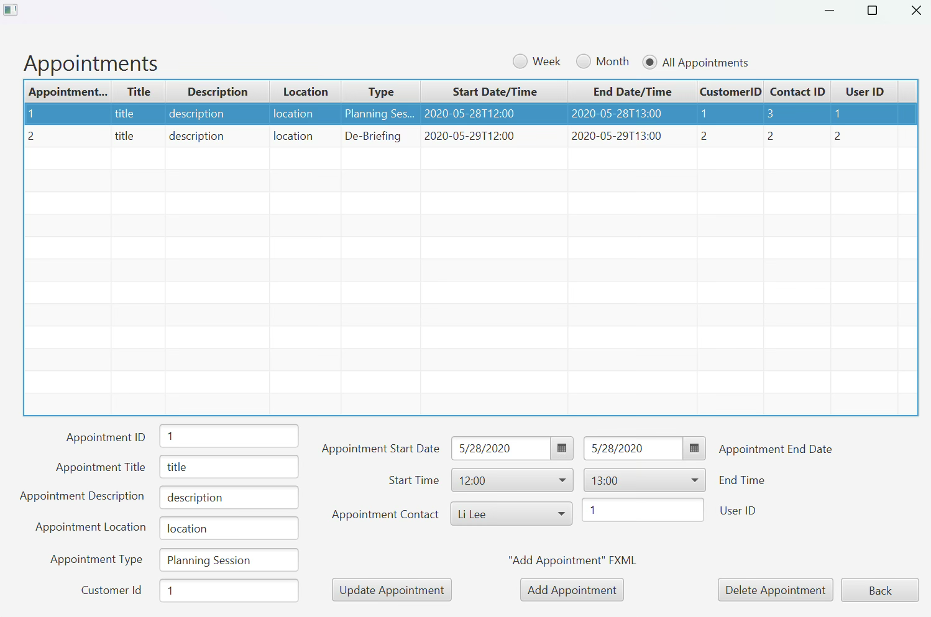

On the top of the table, radio buttons Week, Month, and All Appointments may be selected to narrow the table to a more specific query. of “Week”, “Month”, or “All Appointments”. If Week is selected, because there are no appointments for this upcoming week currently on the client schedule database, no data is displayed.

In the bottom half of the Appointments screen, there are user editable fields including Appointment Title, Appointment Description, Appointment Location, Appointment Type, Customer Id, Appointment Start and End Date, Start Time, Appointment Contact, and User ID. Selecting an appointment populates these fields which can then be updated or deleted manually by the user. After updating or deleting field information, users may click the “Update Appointment”, or “Delete Appointment” to commit the changes to the Appointments Database. Please note that all user editable fields must be filled or the appointment may not be committed to the Database.  
  
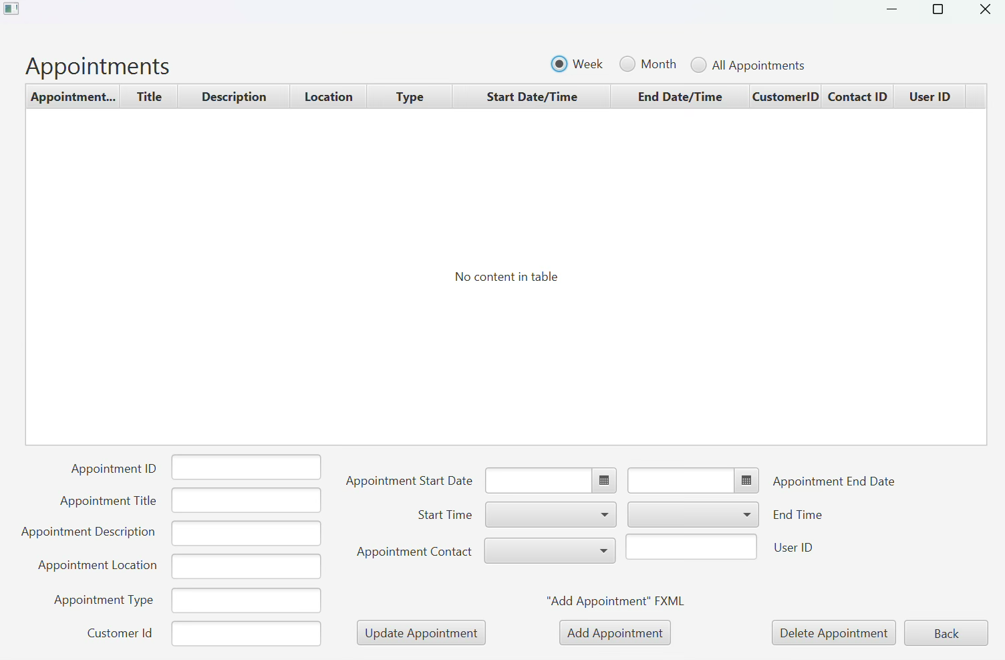

  Selecting Add Appointment from the Appointments screen opens a new screen for adding a new appointment.

**Add Appointments**

  This Add Appointments screen contains the fields also seen on the Appointment screen. While Appointment ID does not accept user input and does not require filling, all other fields must be accurately filled with information that does not break business rules (Start Date, End Date, Start Time, End Time), and references an existing Appointment Contact in order for the Appointment to be generated. Once filled, users may save their appointment with the ‘save’ button, or cancel changes with the ‘cancel’ button.  
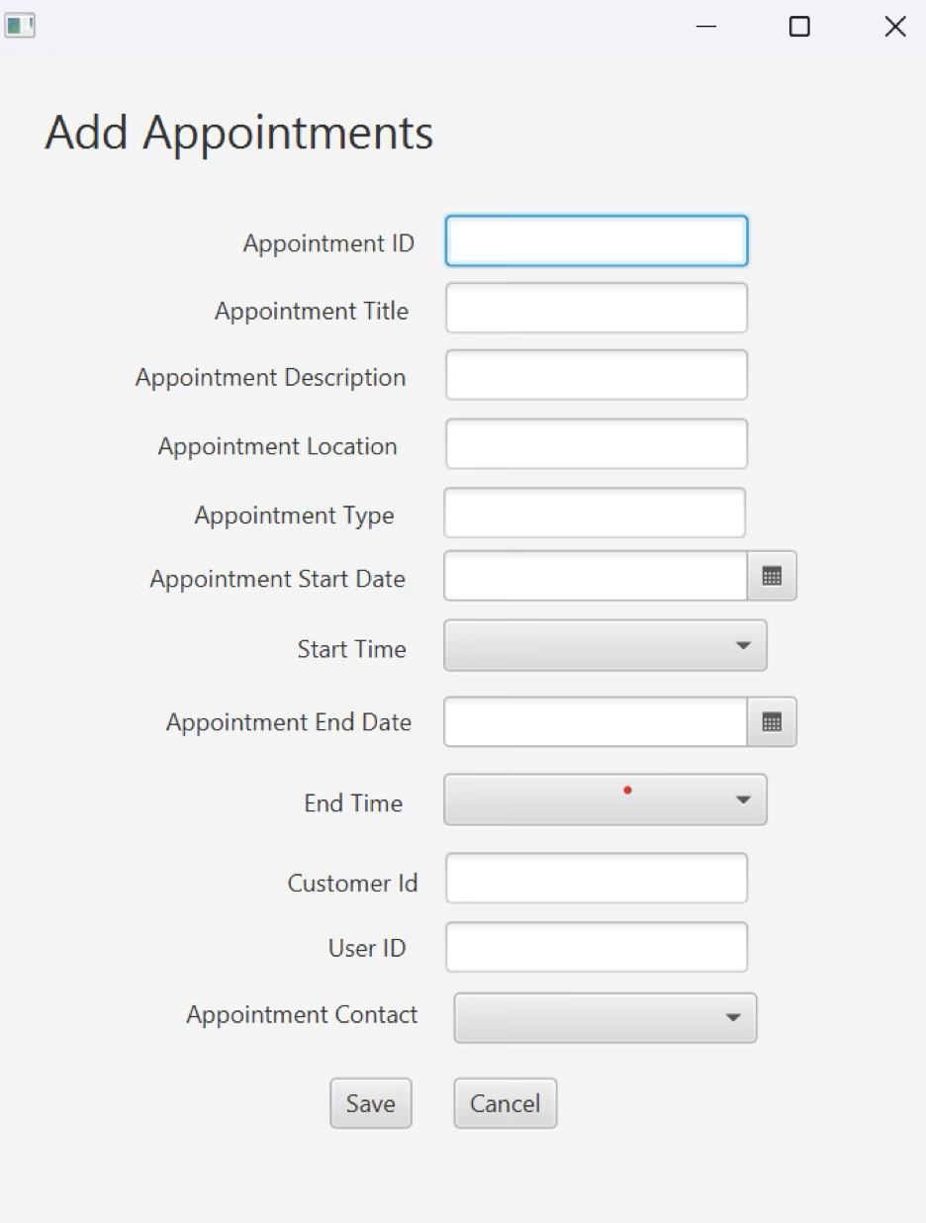

**Customer**

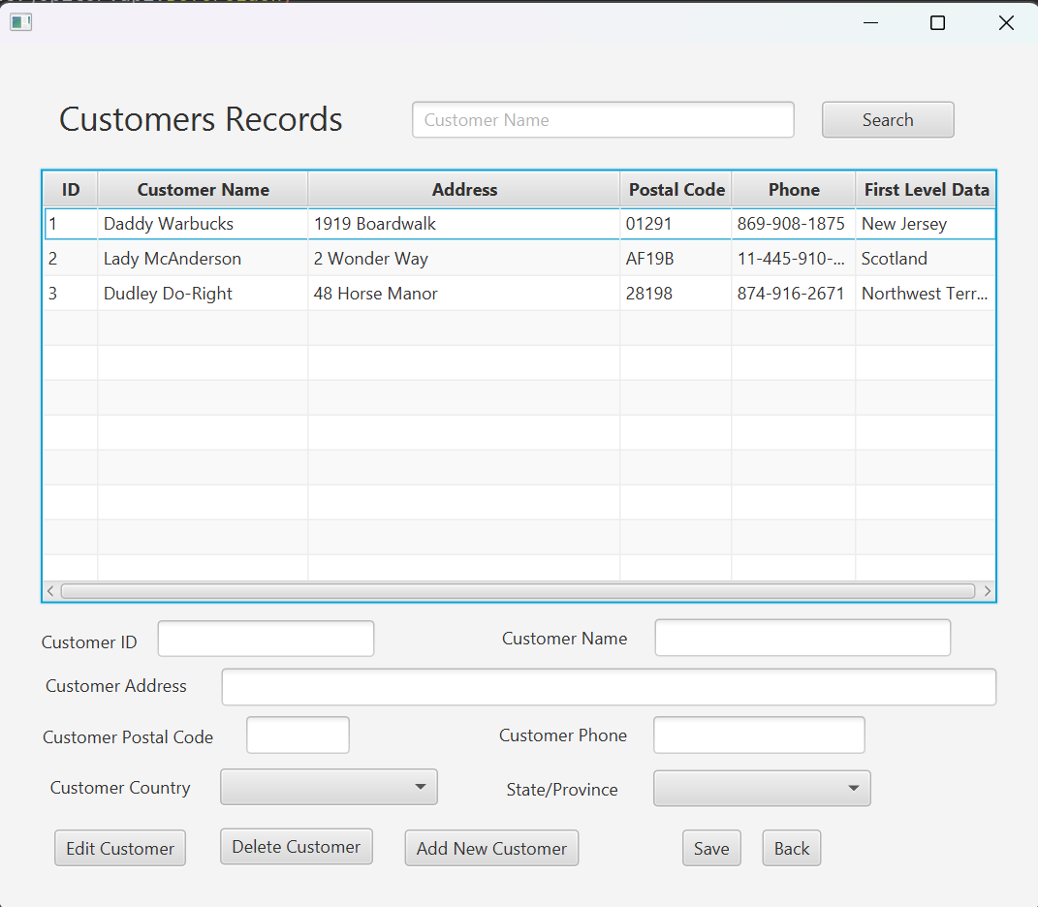 Opening the Customer screen displays a table including [Customer] ID, Customer Name, Address, Postal Code, Phone Number, and the First Level Data indicating the user’s geographic location. Below the customer table, there are user editable fields including the above, Edit Customer, Delete Customer, and Add New Customer buttons.  
 Customers may be **searched** for by name by entering their full first or last name in the Customer Name field, and clicking Search. Partial entries may also show results.  
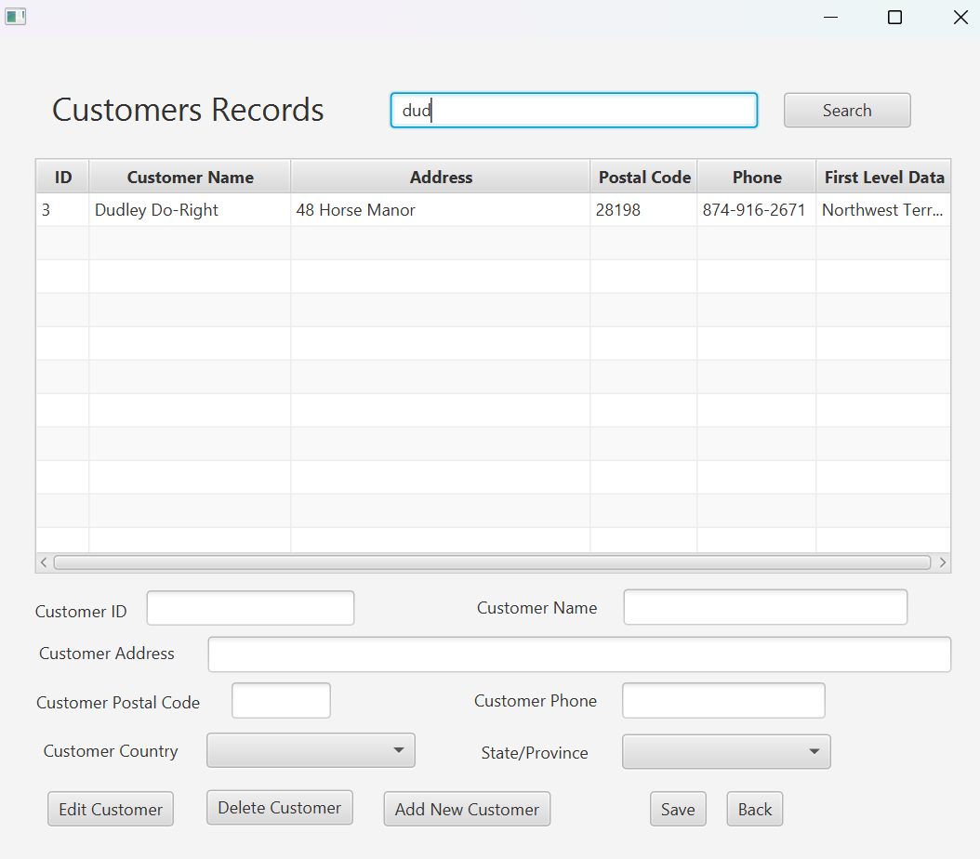  
   
 Selecting **Edit Customer** populates the fields with the customer data so that information may be viewed and edited. Once changes are made, they can be committed to the database by pressing “Save.”  
 Selecting **Delete Customer** confirms that the user would like to delete the customer on record and delete all appointments, before deleting the customer entries in the database. **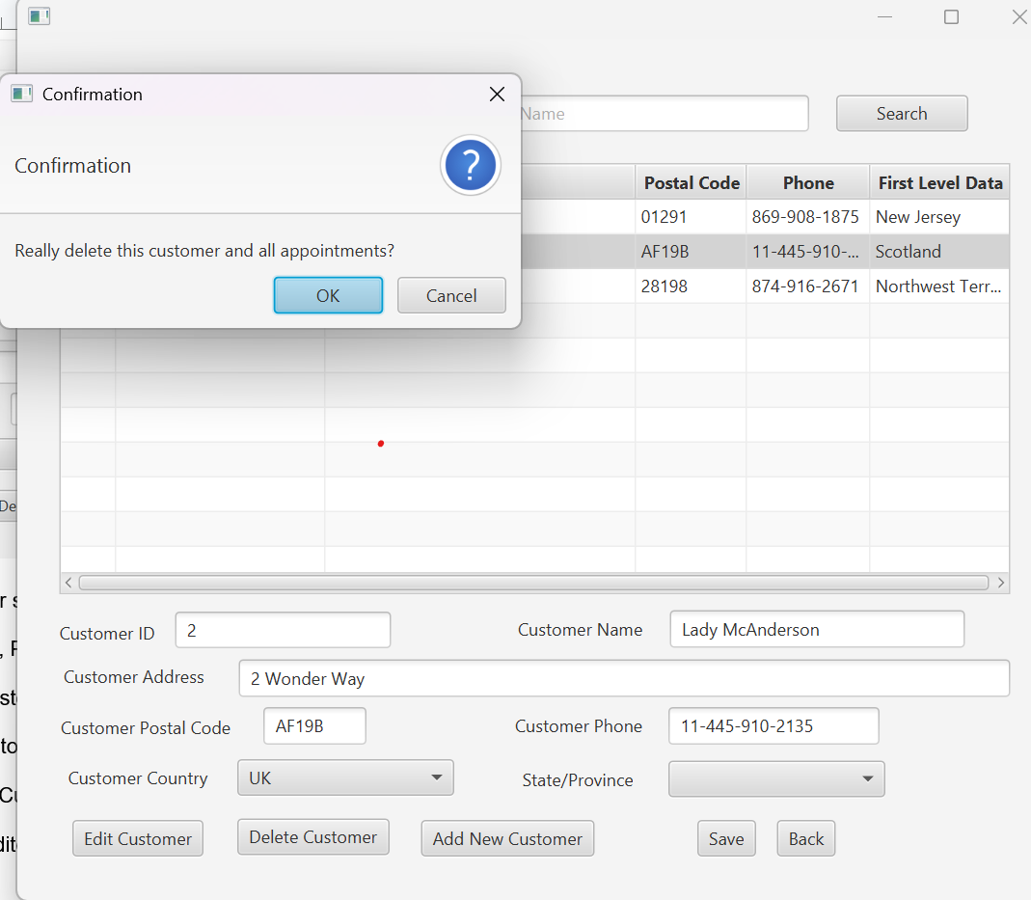  
Add New Customer** may only be pressed when Customers is first opened. In order to blank the values, users may press “Back”, and then press “Customers” to enter the customer management screen. Once the values for the new customer are entered, “Add New Customer” must be pressed to be validated by the scheduling app, before they are committed to the database. At any point, “Back” takes users back to the main menu.

**Reports**

**Contact Schedule**  
Selecting the reports page opens initially to an empty table with fields for Appointment, Title, Description, Location, Contact, Type, Start Date/Time, and End Date/Time. Selecting a contact from the dropdown menu fills the table with all appointments scheduled for that contact. The appointments may then be sorted by selecting the column header of individual fields.   
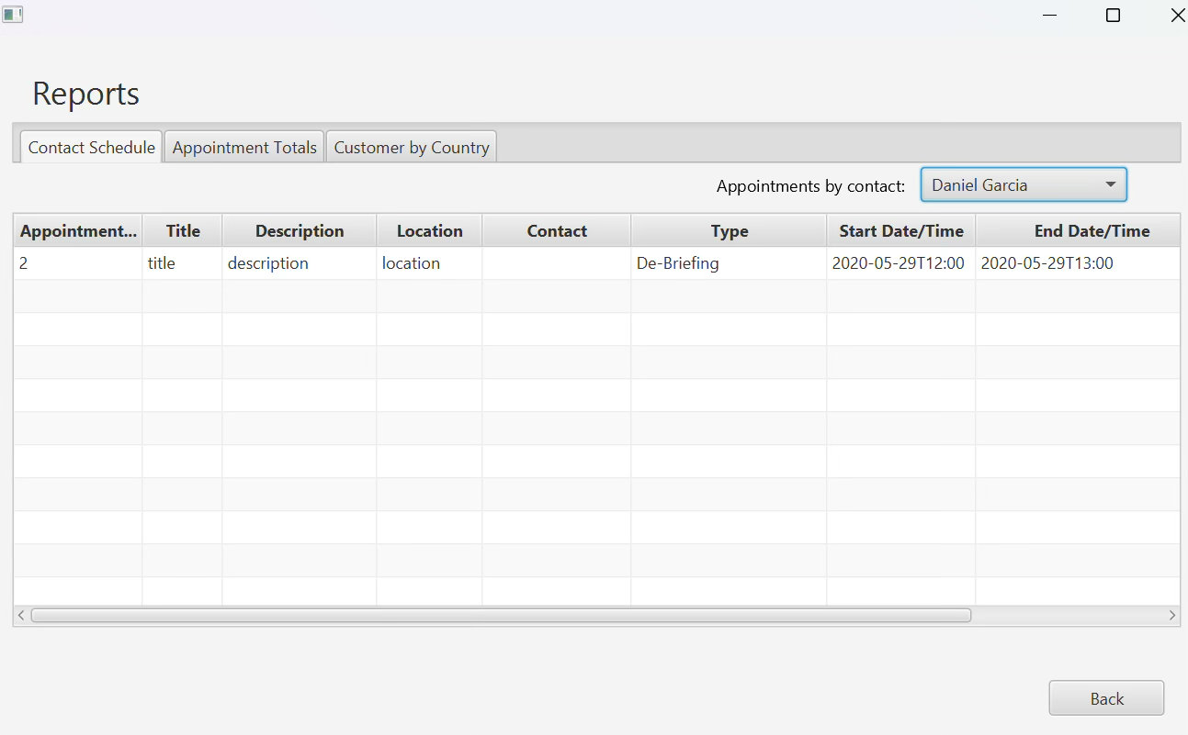

**Appointment Totals**  
 Selecting the “Appointment Totals” tab in Reports loads two populated tables. The first table lists Appointments by Type, and also includes the number of appointments of that type. The second table lists appointments by month, and includes the number of appointments for that month.

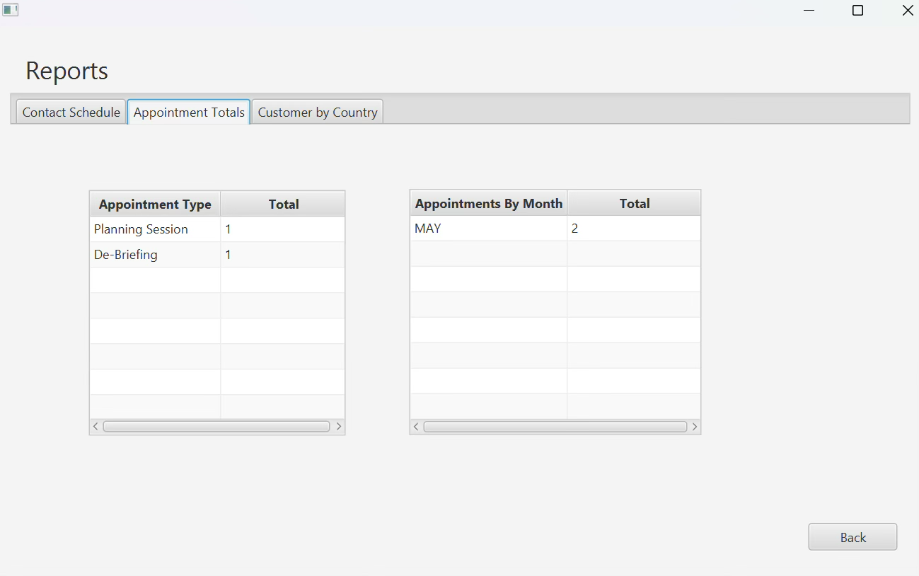

**Customer by Country**

The third tab in Reports includes a table listing customers by country. The table lists the countries of customer contacts, and the total number of customers by each country. 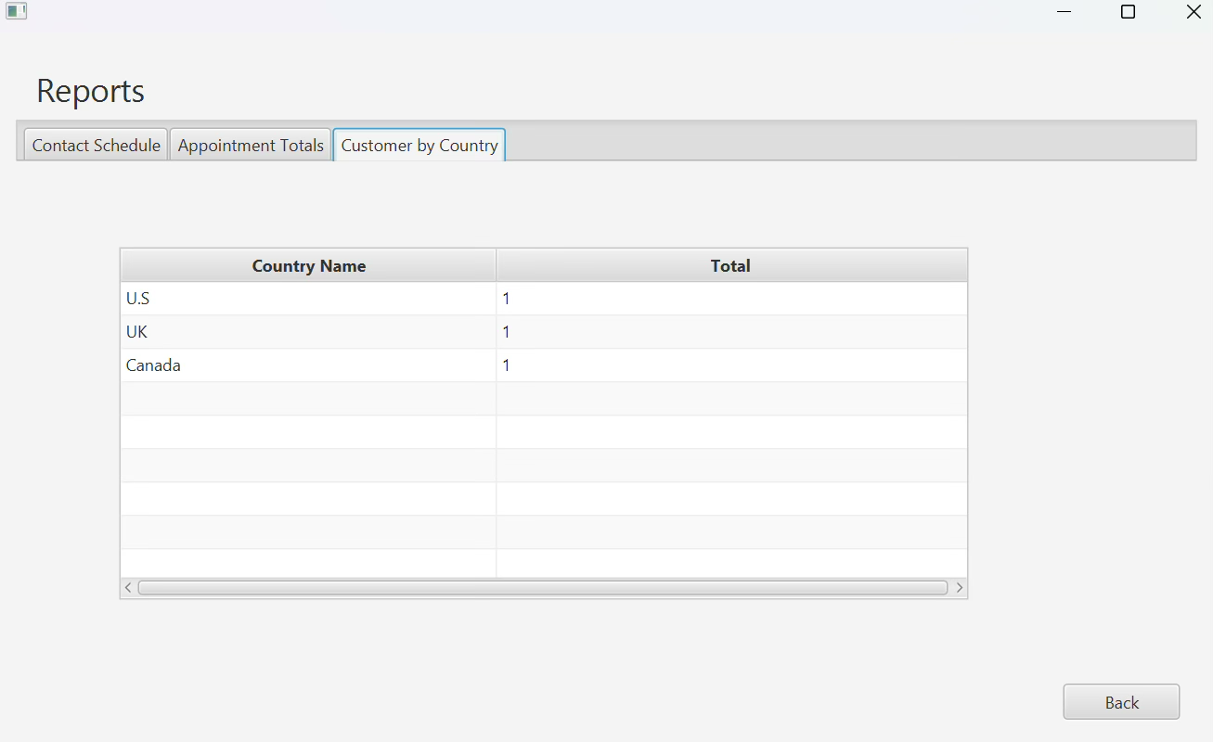

At any time, users may press Back to return to the main Menu.